horizontal line

Project Summary

|  |  |
| --- | --- |
| Batch details | PGP DSE GGN Jun 20 – Aug 20 |
| Team members | Abhishek Prasoon, Apoorv Jain, Harshit Bharrdwaj, Sudeep Kadyan and Urvashi Panwar |
| Domain of Project | Salary Growth Prediction |
| Proposed project title | Salary Prediction of Graduates |
| Group Number | 6 |
| Team Leader | Sudeep Kadyan |
| Mentor Name | Mr. Shashank Shirude |

Date: 17th March, 2021

Signature of the Mentor Signature of the Team Leader

# 

Table of Contents

|  |  |  |
| --- | --- | --- |
| Sl NO | Topic | Page No |
| 1 | Overview | 3 |
| 2 | Business problem goals | 4 |
| 3 | Topic survey in depth |  |
| 4 | Critical assessment of topic survey |  |
| 5 | Methodology to be followed |  |
| 6 | References |  |

Project Details

# OVERVIEW

More than a million engineers enter the global workforce every year. A relevant question is what determines the jobs and salaries these engineers are offered right after graduation. Previous studies have shown the influence of various factors such as college reputation, grades, the field one specializes in and market conditions for specific industries. An important input which such analyses do not have is a standardized measures of job skills done at the time of completion of studies.

We present here Aspiring Minds' Employability Outcomes 2015 (AMEO 2015), a unique dataset which provides engineering graduates' employment outcomes (salaries, job titles and job locations) together with standardized assessment scores in three fundamental areas - cognitive skills, technical skills and personality. Coupled with biodata information, AMEO 2015 provides an opportunity for a unique and comprehensive study of the entry level labour market.

The data could be used to make an accurate salary predictor, but also understand what influences salary and job titles in the labour market. We will perform analysis based on the various factors such as college grades, candidate skills, proximity of the college to industrial hubs, the specialization one has, market conditions for specific industries, etc to answer a relevant question, what determines the salary and the jobs these engineers are offered right after graduation.

# 

# 

# Business problem statement (GOALS)

1. What would you achieve by this project?

We will predict annual salaries of engineering graduate and factors affecting them.

1. How would this help the business or clients?

It will help the Ed-tech companies and education institutions to better understand the industry trends, and to introduce the industry-required skills in the curriculum.

For a candidate perspective it will provide satisfactory salary assurance as a professional.

1. What is the further scope of the project?

Automated web-based job portal with real-time salary predictor according to the details provided.

1. Limitation of the project

Our model is not a generalized model but specific to only candidates from engineering or any technical background.

# TOPIC SURVEY IN BRIEF (200-250 words)

1. Problem understanding

Banks provide loans to the customer based on criterias which are not standardized.

1. Current solution to the problem

Manual intervention in lending loan to applicants

1. Proposed solution to the problem

Algorithm and ML driven loan lending to deserved applicants

1. Reference to the problem

Cite blogs, articles or startups in this domain

# 

# CRITICAL ASSESSMENT OF TOPIC SURVEY (50-100 words)

1. Find the key area, gaps identified in the topic survey where the project can add value to the customers and business
2. What key gaps are you trying to solve ?

# 

# METHODOLOGY TO BE FOLLOWED (Follow 1-2-3-4-5)

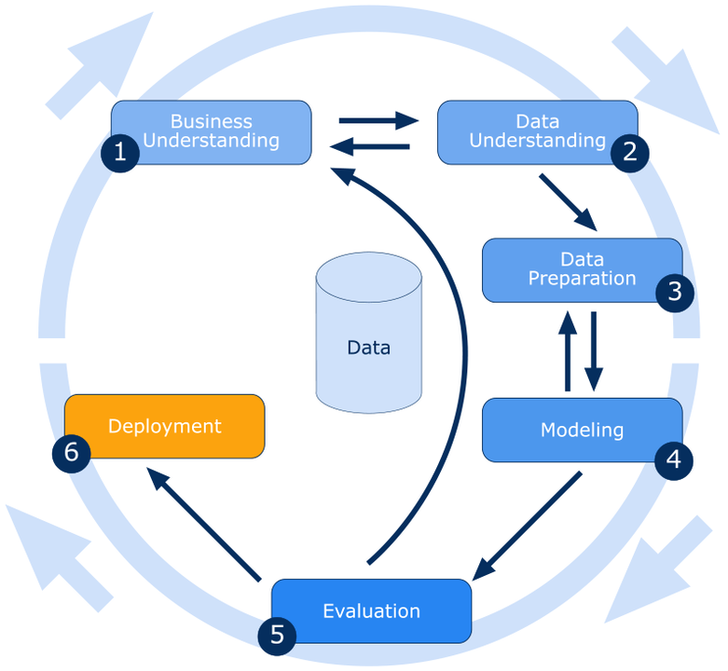

# Reference documents of CRISP-DM

1. <https://paginas.fe.up.pt/~ec/files_0405/slides/02%20CRISP.pdf>
2. https://en.wikipedia.org/wiki/Cross-industry_standard_process_for_data_mining

REFERENCES (Provide at least 10 references for the project proposal)

1. Bergmann, P. G. (1993). Relativity. In *The new encyclopaedia Britannica* (Vol. 26, pp. 501-508). Chicago, IL: Encyclopaedia Britannica.
2. Arno, S. F., & Allison-Bunnell, S. (2002). *Flames in our forest: Disaster or renewal?* Retrieved from <http://www.ebrary.com>

**Notes For Project Team**

*Sample Reference for Datasets (to be filled by team and mentor)*

|  |  |
| --- | --- |
| Original owner of data | Marine Resources Division |
| Data set information | Predicting the age of abalone from physical measurements. |
| Previous relevant journals used the data set | David Clark, Zoltan Schreter, Anthony Adams "A Quantitative Comparison of Dystal and Backpropagation", submitted to the Australian Conference on Neural Networks (ACNN'96). |
| Citation | Dua, D. and Graff, C. (2019). UCI Machine Learning Repository [http://archive.ics.uci.edu/ml]. Irvine, CA: University of California, School of Information and Computer Science. |
| Link to web page | <https://archive.ics.uci.edu/ml/datasets/Abalone> |

### 